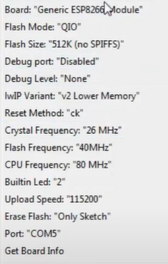

<https://www.youtube.com/watch?v=P8Z-ZHwNeNI>

<https://forum.arduino.cc/t/i-cant-load-simple-code-to-nodemcu/599111>

[SPIFFS] speed : 9600

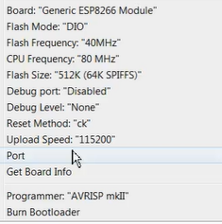

Toos/upload.py line 25, in <module> esptool.main(fakeargs)

cd hardware  
mkdir esp8266com  
cd esp8266com  
git clone <https://github.com/esp8266/Arduino.git> esp8266

Download binary tools (you need Python 2.7)  
  
cd esp8266/tools  
python get.py  
  
Restart Arduino